**S5 GEOGRAPHY**

(Physical Geography)

PAPER 1

**3 hours**

**Uganda Advanced Certificate of Education**

GEOGRAPHY

**(PHYSICAL GEOGRAPHY)**

Paper 1

**3 hours**

# INSTRUCTIONS TO CANDIDATES:

*This paper consists of* ***three*** *sections* ***A, B*** *and* ***C.*** *Answer only* ***four*** *questions.*

*Section* ***A i****s compulsory.*

*Answer* ***one*** *question from Section* ***B*** *and* ***one*** *question from Section* ***C.***

*Any additional question(s) answered will not be marked.*

*Credit will be given for the use of relevant sketch-maps, diagrams and specific examples studied in the field.*

# SECTION A

*Questions* **1** *and* **2** *are* **compulsory**

**COMPULSORY MAPWORK QUESTION:**

Study the 1:50,000 East Africa **(UGANDA) KAMPALA** map extract, part of sheet 71/1, series Y732, Edition 3 – USD and answer the questions that follow:

1. (i) What is the grid reference of the primary trigonometical station

on Naguru hill. (01 marks)

(ii) Name the relief feature found at grid reference 619302. (01 mark)

1. Calculate and state in square kilometers the area occupied by Lake Victoria to the South of Northing 31 between Eastings 59 and 64. (02 marks)
2. Reduce the area shown on the map extract by 2/3 and on the reduced frame mark and name;
3. Any two physiographic regions
4. Any two drainage features
5. Two vegetation types. (10 marks)
6. Calculate the;
7. New scale of the map drawn. (02 marks)
8. Vertical interval for the map extract. (01 mark)
9. Describe the relief of the area shown on the map extract. (08 marks)

# COMPULSORY QUESTION:

# PHOTOGRAPHIC INTERPRETATION

1. Study the photograph provided below and answer the questions that follow:

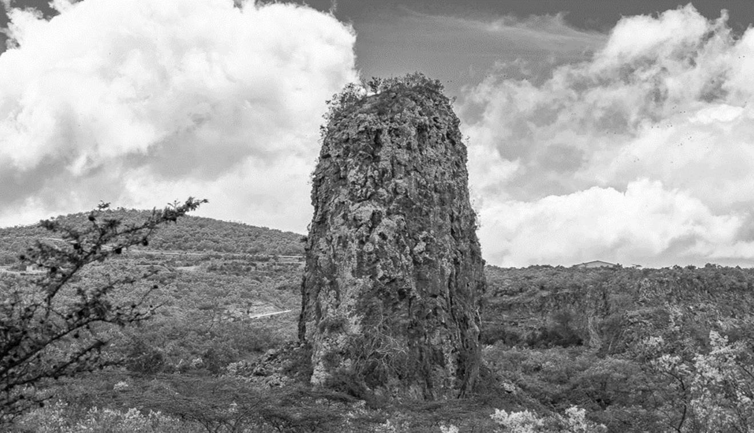

* 1. Draw a landscape sketch of the area shown on the photograph and on it mark and label the:
* Landform features
* Main vegetation type
* **Two** types of human features
* Type of clouds above the horizon (09 marks)
  1. Account for the formation of the prominent landform feature in the middle foreground of the photograph. (04 marks)
  2. (i) Explain the relationship between relief and landuse. (04 marks)

(ii) Examine the importance of the features in the photograph. (06 marks)

* 1. Giving reasons for your answer, suggest an area in East Africa where this photograph could have been taken. (02 marks)

# SECTION B:

*Answer* ***one*** *question from this section*

1. (a) Distinguish between a crater and a caldera (06 marks)

(b) Examine the occurrence of volcanic highlands in East Africa. (19 marks)

1. Account for the formation of wave erosional landforms in East Africa. (25 marks)
2. How Does Charles Darwin’s theory of subsidence explain the formation of coral reefs along the East African coast? (25 marks)

# SECTION C:

*Answer* ***one*** *question from this section*

1. (a) Describe the characteristics of Tropical Rainforests in East Africa.

(10 marks)

(b) Account for the distribution of tropical rainforests in East Africa.

(15 marks)

1. (a) Account for the formation of Latosols*.* (15 marks)

(b) Explain the economic significance of Laterite to the people of East Africa.

(10 marks)

# END